USER MANUAL FOR ARCADEMIA
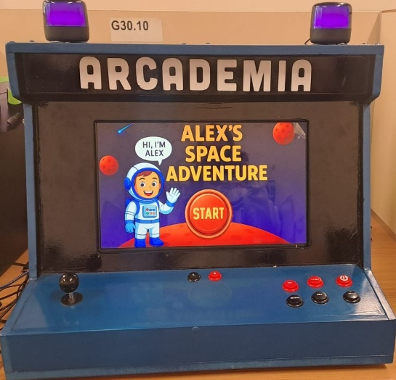

ARCADEMIA

DEVELOPMENT TEAM
Anrich Kruger 44932472
Batlile Mboweni 45304718
Charlton Chivhere 49305115
Kyle Ogle 33744998
Siphokazi Malesa 39212017
Stefan Venter 39066894
Justine Sudbury 40680665
Dumisani Mlangeni 35171995
Sulaiman Sulaman 45427429
Natasha Cloete 45297193
Dean Dube 41456483
Tumelo Maboea 40583295
Project Manager: Melanie Kruger 40919897

Table of Contents
1. Introduction 4
1.1 Background of the application 4
1.2 Purpose of the application 5
1.3 System capabilities 5
1.4 User Roles 6
2. Using the system 7
2.1 Accessing the system in Godot on the Computer 7
2.2 Arcade Machine Controls 8
2.3 Title screen 9
2.4 User Selection Page 10
2.5 Login Page 11
2.6 Signing up 12
2.6.1 Signing up as a Teacher 12
2.6.1 A) Student Management 13
2.6.2 Signing up as a Student 14
2.6.2 A) Avatar Creation 14
2.6.2 B) Sign up page 15
2.7 Navigating the Main Menu 15
3. In-Game Features 17
3.1 Toolbar 17
3.2 Level 1 (Fundamentals) 17
3.3 Level 2 18
3.4 Level 3 19
3.5 Level 4 (Advanced Conditional Logic and Loops) 20
3.6 Feedback 21
3.7 Help 22
3.8 Collecting Spaceship Part 22
3.9 Story Scenes 24
4. Audio and Music System 24
5. HCI Components 25
5.1.1 User (Human) Component 25
5.1.2 If you want to use Computer (System) Component instead of Arcade Box 26
5.1.3 Interaction (Interface) Component 26
6. Possible Errors That Could Be Encountered 27
7. Conclusion 28

List of Figures
Figure 1:Button Allocation 8
Figure 2:Button Allocation 8
Figure 3: Title Screen 9
Figure 4: User Selection Screen 10
Figure 5: Login Screen 11
Figure 6: SignUp Screen for Teacher 12
Figure 7: Student Management Screen 13
Figure 8: Avatar Creation Screen 14
Figure 9: SignUp Screen for Students 15
Figure 10: Main Menu Screen 16
Figure 11: Toolbar 17
Figure 12: Level 1 Gameplay 17
Figure 13: Level 2 Gameplay 18
Figure 14: Level 3 Gameplay 19
Figure 15: Level 4 Gameplay 20
Figure 16: Feedback Popup Screen 21
Figure 17: Help Popup Screen 22
Figure 18: Scoring Page Screen 23
Figure 19: Example of a Story Scene In-Game 24

Introduction
Arcademia is an educational coding game developed using Godot Engine 4, designed to introduce Grade 5 students to fundamental programming concepts through engaging and interactive gameplay. The game features a visual, block-based coding system inspired by Scratch, allowing players to guide Astronaut Alex through various levels by creating sequences of movement commands and actions using an arcade console interface with a joystick and buttons.
Each level challenges players to think critically and plan logically by combining programming blocks that represent commands such as moving right and jumping. The game progressively introduces more complex coding principles—like sequencing, repeat loops, if-statements, and while loops—helping players understand computational thinking concepts in an accessible and enjoyable format aligned with South Africa's CAPS curriculum objectives.
Beyond its educational value, Arcademia emphasizes exploration and problem-solving. Players must navigate the challenges of an alien planet, collect scattered spaceship parts, and assist Alex in repairing the spacecraft to return home. The game's space-themed art style features vibrant visuals combined with modern design sensibilities, creating an immersive learning environment. Integrated avatar customization, scoring systems, and progress tracking enhance engagement and allow students to refine their logical thinking skills across increasingly difficult levels.
Arcademia operates entirely offline on a portable arcade console, making it accessible for South African Model C schools regardless of internet connectivity. By merging game-based learning with structured logic-building mechanics, Arcademia transforms abstract programming concepts into a hands-on adventure that makes computational thinking both intuitive and fun.

Background of the application
Astronaut Alex was on a routine space exploration mission when disaster struck. A comet crashed into the spacecraft, damaging the navigation systems and sending the ship spiralling toward an unknown planet. The crash landing broke the spacecraft into pieces, scattering important parts across the alien world. Now Alex is stranded and needs your help to get home.
You are using Arcademia, a special coding arcade console where young learners solve problems using programming. Using the arcade console controls, you need to help Alex move around the planet and collect all the lost spaceship parts. Your job is to write code using drag-and-drop blocks that tell Alex exactly how to move so the spacecraft can be repaired and Alex can escape.
The planet is full of challenges—gaps to jump over, high platforms to reach, and obstacles in the way. To help Alex succeed, you'll learn important coding skills: simple commands to make Alex move right and jump, repeat loops when Alex needs to do the same action multiple times, if-statements to help Alex make choices based on what's blocking the path, and while loops to keep Alex moving until a goal is completed.
Every level is a new spaceship part to collect. Each spaceship part you collect brings Alex closer to fixing the ship and going home. The coding gets harder as you progress, requiring careful thinking and creative coding. You'll use a visual block-based coding interface where you drag and drop blocks to build your programs using the arcade console's joystick and buttons.
Alex is running out of time. The ship's power is weakening, and the planet is becoming more dangerous. With the Arcademia console and your problem-solving skills, you're Alex's only chance. Your mission begins now. Can you code Alex's way back home?

Purpose of the application
Arcademia introduces Grade 5 learners to computational thinking and coding through engaging gameplay that addresses gaps in the CAPS curriculum. The game teaches key concepts such as sequencing, loops, and conditional statements by transforming abstract programming ideas into concrete actions within a space-themed narrative, making coding accessible for young learners with no prior experience.
In addition, the game aligns with CAPS objectives in Mathematics and Life Skills by developing skills in pattern recognition, logical reasoning, problem-solving, and creative thinking.
Arcademia ensures equitable access by operating entirely offline, overcoming internet connectivity challenges in South African schools. Its low-cost, portable design makes it feasible to teach computational thinking without requiring substantial infrastructure investments. Moreover, the engaging space narrative and game mechanics help foster positive attitudes toward technology and STEM careers.

System capabilities
- The game includes a Blockly-based programming interface that allows players to control a astronaut character’s movements and actions by constructing visual code sequences.
- It operates within a 2D platforming environment filled with collectibles, obstacles, and challenges that encourage problem-solving and logical thinking.
- The system supports dynamic sound effects and background music that adapt to different levels, enhancing the overall gameplay atmosphere.
- Additionally, it features persistent progress tracking, allowing players to save and continue their progress seamlessly between levels.
- Smooth transitions between menus and gameplay scenes ensure a user-friendly experience, while the system’s design allows for easy updates and maintenance, including the addition of new levels, sound assets, and bug fixes to improve performance and extend gameplay content.

User Roles
- Player (or User)
The Player is the primary user who interacts directly with Arcademia: The Blockly Adventure. Players are typically students or individuals seeking to learn the basics of programming logic in a fun and interactive way. Each player is required to create an account, which allows them to save progress, track achievements, and resume gameplay from previously completed levels. Players engage with the game’s visual block-based programming system to guide the astronaut to collect the spaceship part. As they advance, they learn core computational concepts such as sequencing, loops, and conditional logic. The player’s experience is designed to be intuitive and educational, encouraging critical thinking, creativity, and persistence.
- Game Administrator / Moderator
The Game Administrator or Moderator plays a crucial role in managing the overall game environment. This user is responsible for creating, modifying, and managing player accounts, ensuring that only authorized users can access specific features or content. Administrators can control access permissions, such as differentiating between players, teachers, and testers, and can enforce policies to maintain a safe and structured learning environment. They also manage game settings, which include difficulty adjustments, level access, and user data management. Moderators may also monitor user behaviour, prevent exploitation or cheating, and maintain the integrity of the educational experience.
- Teacher / Facilitator
The Teacher or Facilitator acts as a guide and mentor to the players, particularly in educational settings. This role involves monitoring student progress, evaluating performance, and providing explanations of the programming concepts and logical reasoning behind each task. Teachers can use the game’s data analytics or progress reports to identify students’ strengths and weaknesses, allowing them to tailor instruction accordingly. Additionally, facilitators may organize classroom activities or discussions around the game’s levels to reinforce programming theory with hands-on practice. Their involvement bridges the gap between gameplay and formal learning, making Arcademia: The Blockly Adventure a valuable teaching tool.
- Developer / System Administrator
The Developer or System Administrator is responsible for the technical maintenance, updates, and optimization of the game system. Their duties include fixing bugs, implementing new features, and improving performance to ensure smooth gameplay. Developers also handle data backups, server management, and security protocols to protect user information and maintain system reliability. In addition, they may design and release new levels, challenges, or visual enhancements to keep the game engaging and up-to-date. The Developer role is critical in ensuring that the game remains functional, efficient, and scalable as user demands and educational needs evolve.
- Tester
The Tester ensures that Arcademia: The Blockly Adventure operates correctly and delivers a seamless experience for players. Testers are involved throughout the development and beta-testing phases, where they identify bugs, report errors, and provide feedback on gameplay, user interface, and performance. They test different aspects of the system, including functionality, compatibility across platforms, and responsiveness of the block-based programming system. Feedback from testers helps developers refine game mechanics, balance difficulty levels, and enhance overall usability. This role is essential to maintaining the game’s quality, ensuring that players and educators experience a stable and polished product.

Using the system

Accessing the system in Godot on the Computer
Arcademia can be launched and played using the Godot Engine on a computer for development, testing, and demonstration purposes. To run the game on a computer, you can open the project file in Godot Engine 4.
For optimal performance, the computer should meet the minimum specifications of 8 GB of RAM, a dual-core CPU, and a graphics card that supports OpenGL 3.3 or higher. Upon launching, the game automatically adjusts to fit the display resolution and can be controlled using standard keyboard inputs mapped to the coding interface and character navigation commands.

Arcade Machine Controls
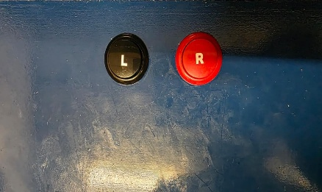
Figure 1:Button Allocation
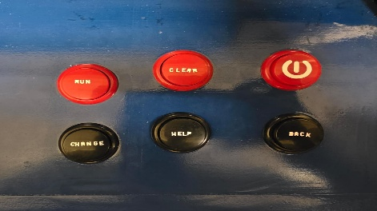
Figure 2:Button Allocation
The arcade version of Arcademia: The Blockly Adventure is played using a dedicated arcade control panel that runs on an HP Elite Desk computer consisting of a joystick and several physical buttons that replace traditional keyboard and mouse inputs.
- Two buttons at the top:
  - Left Click Button – Functions as the standard left mouse click, used for selecting, confirming, and interacting with on-screen elements.
  - Right Click Button – Functions as the standard right mouse click, used to open context menus or perform alternate actions in the Blockly interface (duplicate or delete the code).
- Six side buttons:
  - Top three buttons:
    - Run Button – Used to execute the current Blockly code sequence in the game (equivalent to clicking the “Run” button on-screen).
    - Clear Button – Used to remove or reset all blocks from the workspace (equivalent to the “Clear” button in the interface).
    - Power Button – Used to turn the arcade machine on or off safely.
  - Bottom three buttons:
    - Change/Sequence Change Button – Used to switch between Blockly block sets or change the sequence of commands (Changing between normal sequences to repeat and if statements).
    - Help Button – Opens the Help popup, providing hints and tips for the current level.
    - Back Button – Returns to the previous menu or exits the current screen.
- Joystick Navigation:
The joystick is used to navigate between menus, move the on-screen selection cursor, and interact with buttons or blocks. The Left Click Button confirms selections made using the joystick.
These physical controls provide a tactile and engaging user experience, allowing players to interact with the Blockly interface and game environment intuitively without needing a keyboard or standard mouse.

Title screen
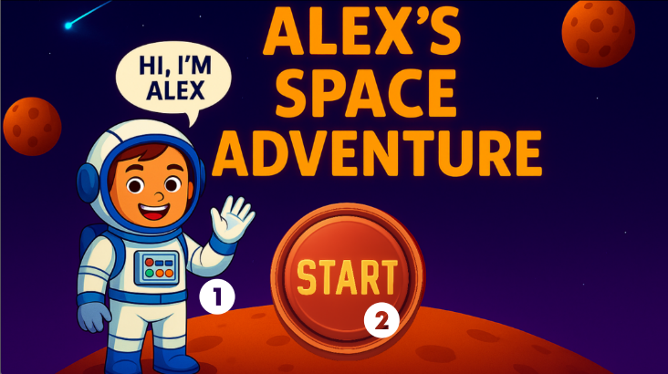
The first page the user will see is the title screen:
Figure 3: Title Screen
- When the game loads, you will see the title screen, featuring Alex, the main character, who welcomes you to Arcademia: The Blockly Adventure. The Title Screen serves as the player’s first interaction point with the game and sets the tone for the adventure ahead through a short animation, background music, and a dynamic space-themed backdrop.
- To begin your adventure, click the large Start button in the center of the screen. This button is clearly visible and responsive, ensuring that players can easily proceed without confusion. You will then be taken to the next page which is the User Selection page, where your space adventure begins.

User Selection Page
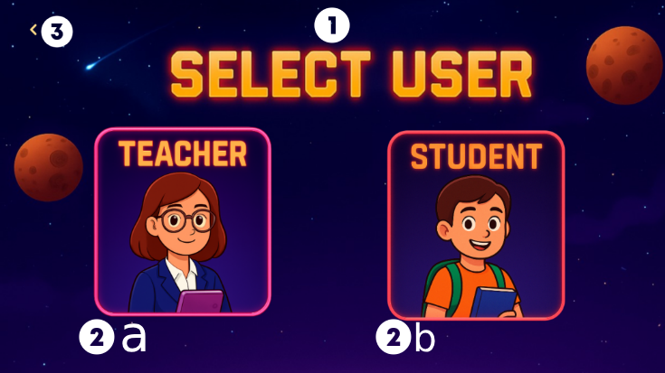
Figure 4: User Selection Screen

- After clicking Start, you will be directed to the User Selection screen. This page allows the game to identify the type of player and tailor the experience accordingly. It serves as a gateway for setting up either a learning or teaching environment within Arcademia: The Blockly Adventure.
- On this screen, you will see two main role options presented with interactive buttons each role to make the selection visually engaging:
  - Teacher – Select this option if you are an educator or facilitator supervising students. Teachers have access to additional tools, such as progress tracking, , and a dashboard showing student performance across different coding challenges.
  - Student – Choose this role if you are playing the game to learn programming concepts and solve coding levels. The student mode provides access to story levels, Blockly coding challenges, and progress-based unlockables designed for an interactive learning experience.
Once you select your role, you will be redirected to the login page to continue your space adventure.
- The User Selection Page also includes a small navigation button at the top-left corner of the screen represented by an arrow icon. Clicking this button will return you to the Title Screen.

Login Page
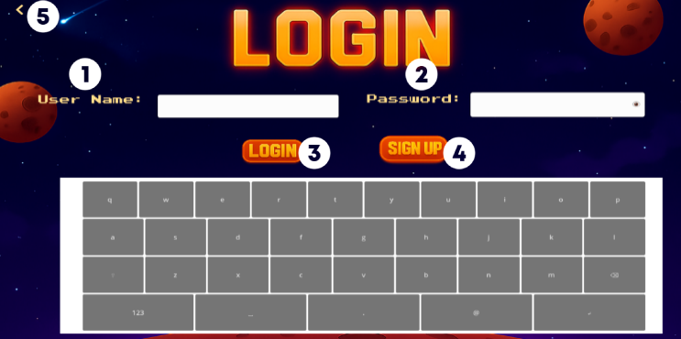
Figure 5: Login Screen

- The user enters their username in the User Name field. This should match the username they previously created or were assigned during registration.
- The user enters their password in the Password field. Passwords are hidden by default to maintain security and privacy. Users can click a small eye icon, to temporarily reveal their password for verification.
- After entering the credentials, the user clicks the Login button. The game will then verify the details and, if correct, grant access to the account and continue the adventure.
- If the user does not already have an account, they can click the Sign-Up button. This will redirect them to the Sign-Up Page, where they can create a new profile by entering required details such as username and password.
- A Back button is located at the top-left corner of the screen. Clicking this allows the user to return to the User Selection Page in case they want to change their role or reconsider their choice.
There is error handling only a 5-digit password can be typed in and if the password or username is wrong and error message is given. The user must log in before the application can be used or they can begin. The teacher side login will direct them to Student Management and the student side to the game.

Signing up

Signing up as a Teacher
If the user does not already have an account, they can create one by clicking the Sign-Up button. This will redirect the user to the Teacher Sign Up Page, where they can set up their credentials and access the game as an educator:
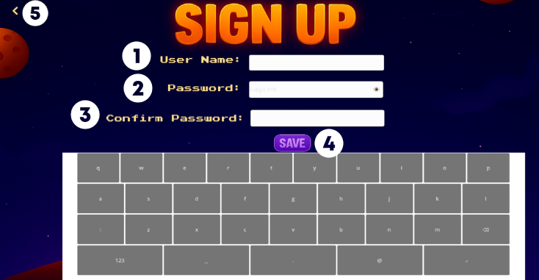
Figure 6: SignUp Screen for Teacher

- The user must choose a username and enter it in the User Name field. Usernames should be unique and easily recognizable for both the teacher and students.
- The user creates a strong password that makes use of a 5-digit password so it can be remember easier.
- The user re-enters the password in the Password Confirmation field to verify that both entries match.
- The user clicks the Save button to create a new account. Once saved, the account will be active and ready for login.
- The user clicks the Back button to return to the Teacher Login Page if they need to log in or make adjustments to their credentials.
Error handeling is included that only a 5-digit password is allowed and that if the user name already exist and error message is given.

A) Student Management
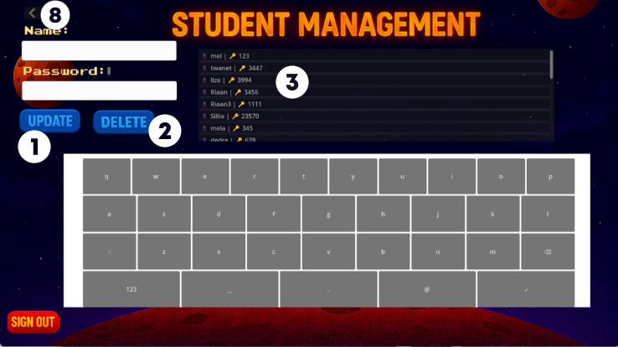
Once logged in, the teacher has access to the Student Management Panel, which allows them to monitor and guide students throughout the game.
Figure 7: Student Management Screen

The teacher can:
- Update student details or accounts — Modify usernames, progress data, or access permissions to reflect current learning requirements.
- Delete student accounts — Remove accounts when students no longer participate or when accounts are outdated.
- Monitor student progress — Track individual or class-wide progress to evaluate learning outcomes and engagement.
- Reset passwords — Assist students who encounter login issues or forget their credentials.
- Review gameplay data and achievements — Analyze how students interact with the game, including their problem-solving strategies and completion rates.
- Manage class groups or sessions — Ensure each learner is linked to the correct class, and oversee multiple groups simultaneously for structured learning.
- The user clicks the Back button to return to the Teacher Login Page after completing student management tasks.

2.6.2 Signing up as a Student
Upon signing up, students will first be directed to the Avatar Creation Page to create a personalized character before accessing the game. This ensures that each student has a unique in-game representation, enhancing engagement and identity within the game world

A) Avatar Creation
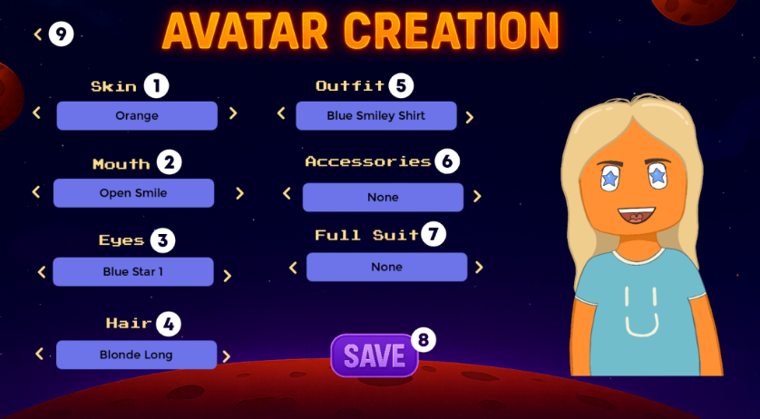
The user needs to create an avatar before signing up for the game, allowing the student to customize the appearance of their character using various options:
Figure 8: Avatar Creation Screen

- Skin Selection — The user selects their preferred skin tone using the left or right arrow buttons.
- Mouth Selection — The user customizes the mouth appearance by choosing from the available options using the arrow buttons.
- Eyes Selection — The user selects their preferred eye style or color using the arrow buttons.
- Hair Selection — The user customizes the hairstyle and color using the arrow buttons.
- Outfit Selection — The user chooses a preferred outfit or clothing style using the arrow buttons.
- Accessories Selection — The user selects accessories, such as hats or glasses, using the arrow buttons.
- Full Suit Selection — The user can select a complete outfit option using the arrow buttons, overriding individual clothing items if desired.
- Save Avatar — The user clicks the SAVE button to confirm their selections and save the avatar to their profile.
- Back Button — The user can click the Back button to return to the Student Login Screen if they wish to make changes later or cancel the creation process.

2.6.2 B) Sign up page
After creating an avatar, the user is redirected to the Student Sign Up Page to create their account credentials.
Figure 9: SignUp Screen for Students
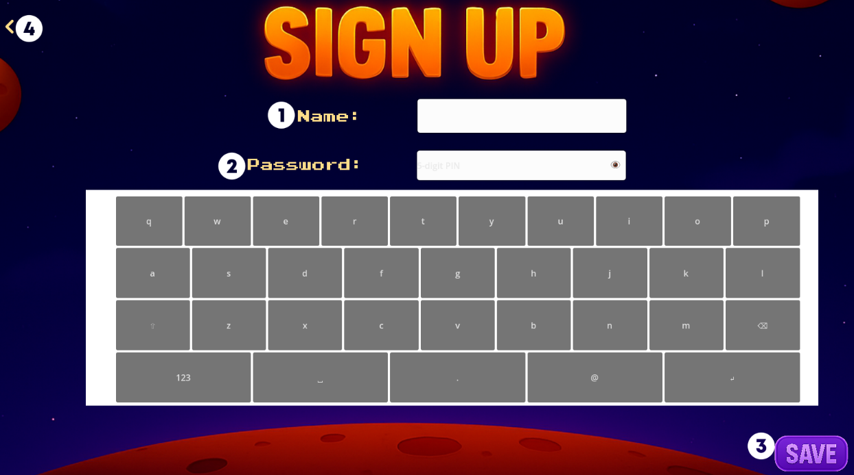
- Username — The user enters a unique username in the User Name field. Usernames should be easy to remember and identifiable for both students and teachers.
- Password — The user creates a strong password containing a combination 5-digit passwords security and make it easier for kids to remember.
- Save Account — The user clicks the Save button to create their account. Once saved, the account is active, linked to the created avatar, and ready for login.
- Back Button — The user can click the Back button to return to the Avatar Creation Page to make adjustments to their character before finalizing the account.
Error-handeling is done that only allows 5-digit passwords and if the user name already exist and error message is given.

Navigating the Main Menu
After successfully signing up or logging in, the user is automatically redirected to the Main Menu screen. This screen serves as the central hub from which the player can access all gameplay content, view progress, and manage their account. The Main Menu is designed to be intuitive and visually appealing, with clear navigation options for the user.
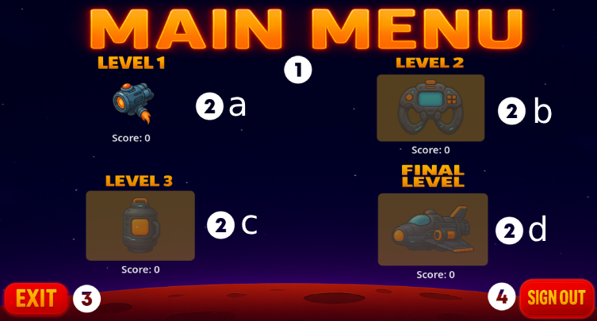
Figure 10: Main Menu Screen

- Game Levels Display — The user can view the available game levels: Level 1, Level 2, Level 3, and the Final Level. Each level displays a corresponding image and the user’s score or progress, allowing them to track their achievements and identify which levels have been completed. Levels that are locked or not yet unlocked may be visually distinct to indicate restricted access, and they gain access by finishing a previous level.
- Selecting a Level — To begin playing, the user clicks on any available level. This action loads the corresponding game environment, along with any relevant challenges, objectives, and pre-programmed scenarios. Players can use the visual Blockly interface to control their character within each level, applying the coding concepts learned throughout the game.
- Exiting the Game — If the user wishes to close the application, they can click the EXIT button located at the bottom left corner of the screen. Selecting this option will safely close the game while preserving the user’s progress and account data.
- Signing Out — To log out of their account, the user clicks the SIGN OUT button located at the bottom right corner of the screen. This ensures that another user can log in safely without interfering with saved data or ongoing game sessions. After signing out, the user is redirected back to the Start page.

In-Game Features
Before and after each level, a special pack of scenes will be played to progress the story of the game. Just click anywhere on the screen to continue.

Toolbar
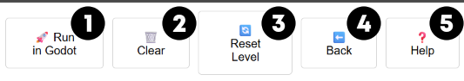
Figure 11: Toolbar

- The user clicks Run in Godot to start the gameplay, which reads your blocks(input) and displays the avatar moving accordingly.
- Used to clear the user’s blocks, allowing for a fresh start at building the required logic to complete the game.
- Reset Level button resets the game back to the first tile without clearing your inputted blocks.
- The user clicks on Back button to return to the Main Menu Screen.
- A pop up after clicking this button will appear with tips and hints to completing the level the user is currently on, successfully.

Level 1 (Fundamentals)
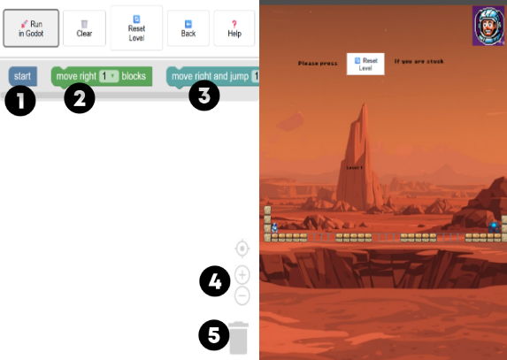
Figure 12: Level 1 Gameplay

Level 1 introduces players to the basic Blockly commands and the fundamentals of programming logic within Arcademia: The Blockly Adventure. The objective is to guide the player avatar toward the spaceship part while learning to sequence commands effectively.
- Start Block — The “start” block serves as the entry point for all programs. Any sequence of commands must begin with this block in order for the logic to execute correctly. This block ensures that the program knows where to begin execution in each level.
- Move Right Block — The “move right … blocks” block allows the player avatar to move horizontally to the right. The user can input the number of steps the character should take, giving them control over how far the avatar travels toward the target spaceship part.
- Move Right and Jump Block — The “move right and jump …” block combines horizontal movement with a jump. The player decides how many steps or jumps the avatar should perform.
- Zooming Properties — Players can zoom in or out of the Blockly workspace to better fit their blocks within the viewable area. This feature ensures that even complex programs with multiple nested commands remain readable and manageable.
- Delete Block Button — The delete button allows users to remove unwanted blocks from their workspace. This feature helps players correct mistakes, optimize their code sequences, or start over if needed. It is essential for experimentation and learning through trial and error.

Level 2
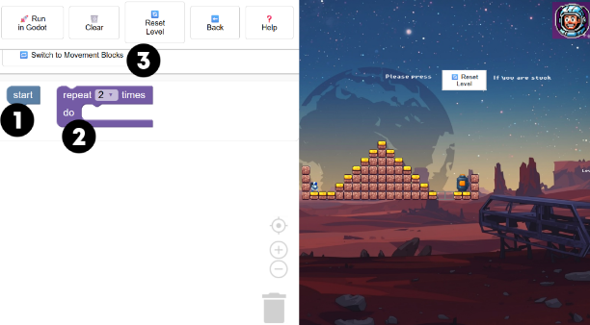
Figure 13: Level 2 Gameplay

Level 2 introduces loops and repetition to help players optimize their code and understand how repetitive actions can be executed efficiently. The goal is still to guide the player avatar to the spaceship part, but now users will learn how to reduce redundancy in their sequences.
- Start Block — The “start” block remains the first block in every program. All logic must begin here for the program to execute correctly. This ensures that the avatar knows where to begin processing instructions.
- Repeat … Times Do Block — The “repeat … times do” block allows users to group multiple instructions and execute them a specified number of times. For example, a user can group move right and jump blocks to have the avatar move across multiple platforms without manually duplicating blocks. This block teaches users the concept of iteration and helps reduce the number of individual commands, making their programs cleaner and more efficient.
- Switch to Movement Blocks Button — The “Switch to Movement Blocks” button allows the user to return to the basic set of blocks: start, move right … blocks, and move right and jump …. This feature helps players mix loops with single movement instructions, encouraging flexibility in designing sequences and reinforcing the concept of combining simple and complex commands.

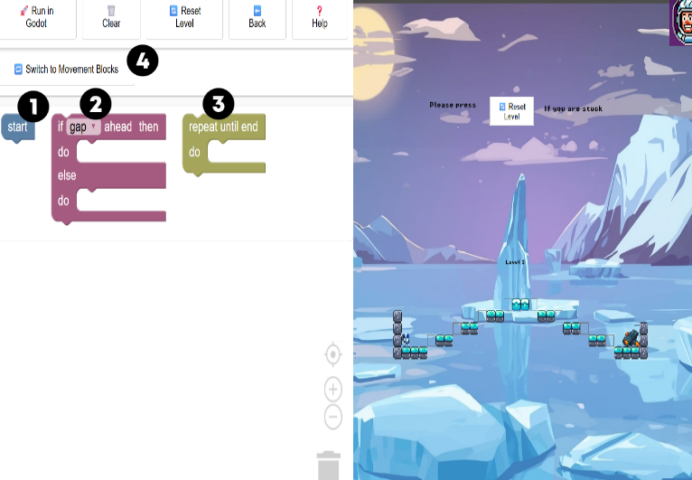
Level 3
Figure 14: Level 3 Gameplay

Level 3 introduces conditional logic and repeat-until loops, helping players make decisions dynamically and automate sequences based on environmental conditions. The goal remains to guide the avatar to the spaceship part.
- Start Block — The “start” block is still the first block in any program. All instructions must begin here to ensure correct execution of the sequence.
- If Gap/Ground Ahead Then Do … Else Do … Block — This block introduces conditional statements, allowing the avatar to make decisions depending on whether a gap or solid ground is detected ahead. If Gap Ahead: The avatar can execute a jump or another instruction to safely cross the gap. Else (Ground Ahead): The avatar continues moving forward normally. This teaches players the concept of decision-making in programming, where actions depend on conditions in the environment.
- Repeat Until End … Block — The “repeat until end …” block allows the player to instruct the avatar to continue performing a sequence of actions until it reaches the spaceship part. This block reduces the need for repetitive manual sequences and demonstrates event-driven loops. Players learn to rely on the game environment to determine when to stop repeating actions.
- Switch to Movement Blocks Button — The “Switch to Movement Blocks” button allows players to return to the basic movement blocks: start, move right … blocks, and move right and jump …. This flexibility encourages combining simple movements with advanced logic for more efficient solutions.

Level 4 (Advanced Conditional Logic and Loops)
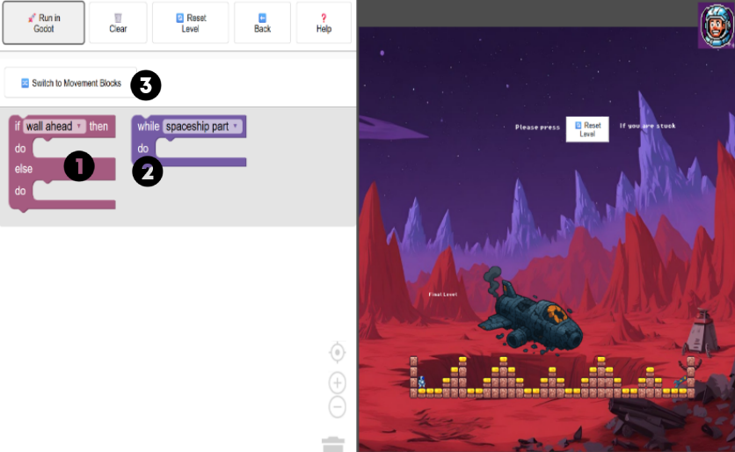
Figure 15: Level 4 Gameplay

Level 4 is the final level, designed to consolidate all the programming concepts introduced in previous levels. Players must combine conditional statements, loops, and movement blocks to successfully guide the avatar to the spaceship part while avoiding obstacles like walls
- If Wall Ahead / No Wall Ahead Then Do … Else Do … Block — This advanced conditional block allows the avatar to make decisions based on the presence of walls in its path. The avatar will decide what instruction to follow based on wall ahead or no wall ahead.
- While Spaceship Part Do … Block — This block allows the avatar to repeat instructions continuously until it reaches the spaceship part. Players can combine this with movement and conditional blocks to automate sequences efficiently, reducing the need for repetitive manual input. It reinforces the programming concepts of loops and condition-based repetition.
- Switch to Movement Blocks Button — The “Switch to Movement Blocks” button lets the player return to the basic core blocks: start, move right … blocks, and move right and jump …. This provides flexibility to combine simple and advanced logic blocks for optimal solutions.

Feedback
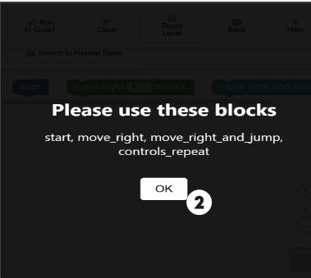
Figure 16: Feedback Popup Screen

- Feedback Popup — This mean that the player has not used all the blocks and must make use of all of them before the game can run.
- Closing the Popup — Clicking the “Ok” button closes the feedback popup and returns the player to the Blockly workspace, allowing them to make corrections and continue playing the level.

Help
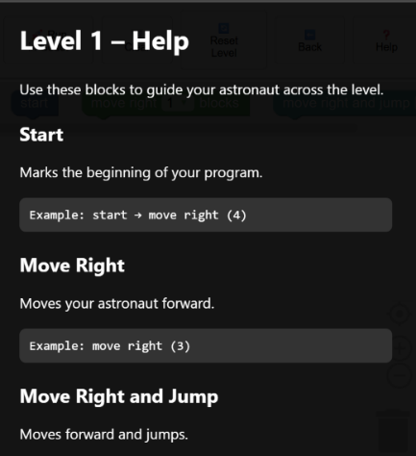
Figure 17: Help Popup Screen

The Help feature in Arcademia: The Blockly Adventure is designed to provide assistance and guidance to players who may be unsure of how to proceed in a level or how to use the available blocks effectively
- Accessing Help — When the player clicks the Help button located on the level interface, a help popup screen appears. This popup provides context-sensitive hints and tips specific to the current level and the challenges the astronaut faces.

Collecting Spaceship Part
The Spaceship Part Collection feature is a core element of gameplay in Arcademia: The Blockly Adventure. Players must guide their avatar through each level to locate and collect spaceship parts while completing the level’s programming challenges.
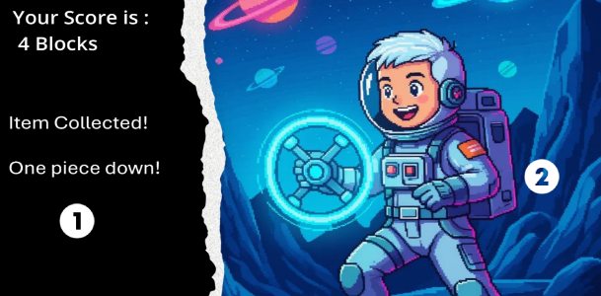
Figure 18: Scoring Page Screen

- Scoring Page — Upon collecting a spaceship part, the game will automatically display a scoring page summarizing the player’s performance. This page includes, the number of blocks used to complete the level (fewer blocks indicate more efficient logic) helping the player track progress toward completing the overall spaceship.
- Progression — After reviewing the score, the player can click anywhere on the screen to proceed to the next level or story scene. This ensures a smooth flow between gameplay and narrative elements. The progression is then send to the Student Management page.

Story Scenes
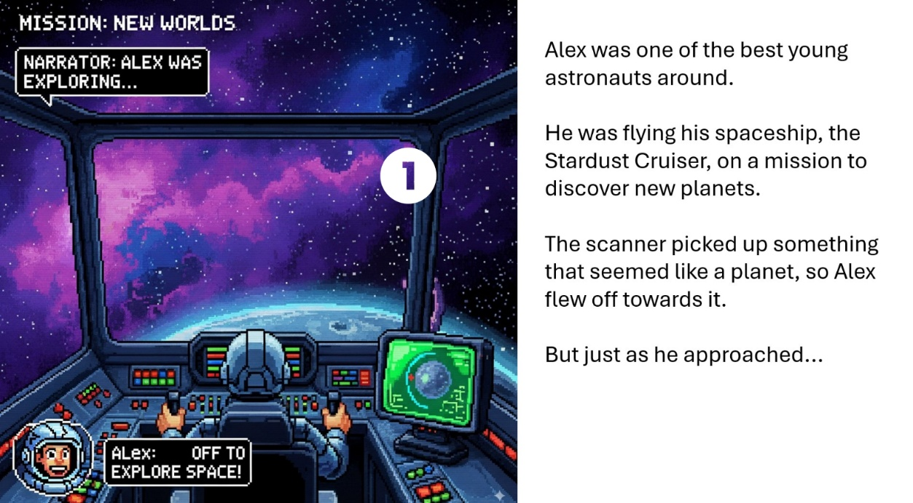
Figure 19: Example of a Story Scene In-Game

- Before and after every level, story cutscenes will be displayed for the user to allow them to follow along with the story and understand more about the next goal of the astronaut’s journey, providing narrative context and motivation for the upcoming challenges. The user can click anywhere to continue on with the story and progress further into the game.

Audio and Music System
The Audio and Music System in Arcademia: The Blockly Adventure was carefully designed to enhance immersion and create an emotionally engaging experience for players throughout their journey. The system dynamically responds to player actions and game events, ensuring that every movement, interaction, and scene transition is accompanied by suitable sound feedback. Background music plays a vital role in setting the tone for each environment—ranging from calm, atmospheric melodies in the main menu to energetic, exploratory tracks during gameplay. To maintain freshness and avoid repetition, the level soundtrack selection is randomized through a smart queue system that cycles tracks without immediately repeating the same song, moving each played track to the back of the list. Smooth crossfades between songs ensure seamless transitions between levels and menus, preventing abrupt audio changes that could disrupt the player’s focus. Sound effects such as footsteps, jumps, and landings are crafted in a pixel-retro but aesthetic, reinforcing the nostalgic, arcade-inspired theme of the game. Each sound effect contributes to the game’s tactile feedback system—making the world feel alive and responsive. The audio engine also adjusts playback volume levels across different audio categories to maintain balance; for instance, background music is slightly quieter to let important sound effects stand out. Together, the music and sound effects form a cohesive layer of atmosphere and feedback that not only elevates the storytelling and gameplay rhythm but also helps players intuitively understand success, failure, and progress within the game.

HCI Components

User (Human) Component
This focuses on how players interact with the game system, considering their cognitive, physical, and emotional traits.
- Cognitive Abilities
  - Players use memory and attention to construct logical sequences with visual code blocks.
  - Problem-solving is central to gameplay, especially when navigating obstacles and collecting spaceship parts.
  - Users also practice planning and debugging sequences, which develops analytical thinking and reasoning skills.
- Physical Abilities
  - Hand-eye coordination is required for dragging and dropping blocks, interacting with the on-screen keyboard, and customizing avatars.
  - Reaction time is important for responding to dynamic gameplay elements such as feedback popups, moving obstacles, or jump timing.
- Emotions and Motivation
  - Engagement is fostered through interactive levels, story progression, and avatar creation.
  - Enjoyment is enhanced by music, visuals, and the sense of achievement from completing levels.
  - Frustration may occur when blocks are misused or levels are failed, mitigated by help popups and hints.
- Experience Level
- Designed to accommodate novice users (students new to programming) through visual coding and guided feedback.
- Intermediate and expert users (teachers, testers, developers) interact with more advanced features like student management and system updates.

If you want to use Computer (System) Component instead of Arcade Box
This includes the hardware and software that powers the game.
- Game Software
  - Built using Godot Engine 4, with mechanics based on Blockly-style logic.
  - UI/UX design includes smooth transitions, persistent progress tracking, and modular level structure.
- Input Devices
  - Mouse desktop interaction.
  - On-screen keyboard for login and registration.
  - Arrow buttons for avatar customization.
- Output Devices
  - Monitor displays GUI elements, levels, and avatars.
  - Speakers provide dynamic sound effects and background music.
- Platform
- Runs on desktop devices (PC and laptop).

Interaction (Interface) Component
This is the communication layer between the user and the system.
- Graphical User Interface (GUI)
  - Menus: Title screen, Main Menu, Level selection
  - Buttons: START, SAVE, EXIT, SIGN OUT, HELP, BACK, RESET LEVEL
- Feedback
  - Visual: Score updates, spaceship part collection, feedback popups
  - Audio: Adaptive sound effects and music per level
  - (No haptic feedback mentioned)
- Navigation Controls
  - Avatar customization via arrow buttons
  - Level selection from Main Menu
  - Role-based login and sign-up flows
- Consistency
  - Uniform layout across screens (e.g., login, sign-up, avatar creation)
  - Reusable block types across levels with consistent logic structure
- Accessibility
- Visual block-based coding lowers barrier for beginners
- Clear button labels and intuitive navigation

Possible Errors That Could Be Encountered
Challenges | Description | Cause | Solution
“Lambda capture freed” error | Occurs during audio playback when the sound system tries to access a destroyed object. | Audio objects are being prematurely destroyed before playback completes. | The issue is automatically managed through safe cleanup timers in the code, so no user intervention is required. Developers should ensure safe playback handling remains implemented.
Missing sound files | Game audio such as music or sound effects fails to play. | Missing or incorrectly located .wav or .mp3 files. | Ensure that all sound assets are correctly stored in the res://music/ and res://sfx/ directories within the Godot project. Verify file paths in the AudioManager script.
Player not moving | The player character does not respond to Blockly commands. | Disconnected or incomplete Blockly logic sequences in the visual editor. | Check that all code blocks are properly connected in the Blockly editor and that the sequence starts with the Start block.
Scene not loading | A level or story cutscene fails to load during gameplay. | Missing or renamed scene file within the project directory. | Verify that all required .tscn files are present and properly referenced in Godot’s Project Tree. Update file paths if necessary.
General gameplay inconsistencies | Minor lag, missing UI elements, or incorrect animations. | Outdated builds, missing dependencies, or incomplete exports. | Perform a project reimport in Godot, clear the cache, and ensure that all assets are correctly linked before exporting the final build.

Conclusion
Arcademia is a thoughtfully designed educational coding platformer that effectively introduces fundamental programming concepts to students through engaging and interactive gameplay. By using a visual, block-based coding system inspired by Google Blockly, players are guided to develop logical thinking and problem-solving skills while progressing through increasingly complex levels. The game balances fun and learning with features like avatar customization, dynamic sound, and meaningful feedback, making it accessible and motivating for novice coders.
Overall, Arcademia serves not only as a game but as a gateway to mastering programming fundamentals in an enjoyable and supportive environment for learners and educators alike.

